2022 Annual Report
Engineering and Geoscience Education Foundation Inc.

President's Message
Thank you to our donors and volunteers for your support in 2022! The following is what your efforts accomplished.
In February 2022 the Foundation committed to selecting a new name that would better reflect its mission. Known as APEGM Foundation Inc. since its inception in 2004, the Foundation has been renamed Engineering and Geo-science Education Foundation Inc. (EGEF). The work, facilitated by Cate Friesen of The Story Source, was es-sentially completed by the end of June, with registration at the Companies Office and CRA following.
In 2022, the Board welcomed one new director, Amber Anderson Skrabek. Amber has a long history of involve-ment with Engineers Geoscientists Manitoba, Friends of Engineering and the Price Faculty of Engineering.
In February, EGEF learned that changes to qualification requirements by Engineers Geoscientists Manitoba would likely result in the eventual phasing out of the Internationally-Educated Engineers Qualification (IEEQ) Program, for which the Foundation had established, in 2014, an endowment fund at the University of Manitoba named APEGM Foundation Inc. (AFI) Bursaries for IEEQ Students. To effectively direct funds to other students of a similar demographic, the Foundation requested a change to the terms of reference and a new name—Dr. Ganpat S. Lodha Bursaries—to honour Dr. Ganpat S. Loha, P. Geo., FGC, founder of the Fund. The Fund will continue to provide bursaries to qualifying IEEQ students as long as the program exists, as well as students with refugee/protected status and permanent residents. The minimum bursary payable to a student is $1,000, and the maximum is $2,500.
In 2021, the Board had committed to board training. Volunteer Manitoba facilitated the online training on March 2, 2022, and The Winnipeg Foundation provided a grant of $700 to cover the cost.
The December 2021 $50,000 donation to the Price Faculty of Engineering, Strategic Initiatives Fund, carried naming rights. For details of events that subsequently unfolded in 2022, please see the article on page 2.
The Foundation's AGM was held June 21. Positions on the Board will be staggered two-year terms, with half the Board being eligible for re-election each year.
On July 13, Allan Silk gave the Board an informative presentation on fund-raising. Our private ask for our new campaign—Removing barriers for tomorrow’s engineers and geoscientists—began in the fall (family, friends). Our public campaign will begin in 2023.

Work on the EGEF’s new website, begun in 2021, kicked into high gear over the summer 2022, with release to the public in mid-September. The new URL is egef.ca.
Sincere gratitude to our donors and volunteer board members for your tremendous contributions to the work of the Foundation in 2022. It’s been a great pleasure to work with you!
Nirdosh Ganske, P.Eng.(SM), President,
Engineering and Geoscience Education Foundation Inc.

If you have any questions about the Foundation please email: info@egef.ca

Bursary Support for IEEQ Students at the Price Faculty of Engineering
In 2014, the APEGM Foundation (now EGEF) provided $100,000 to establish an endowment with the University of Manitoba to provide bursaries to support qualified students in the IEEQ (Internationally Educated Engineers Qualification) Program. The Manitoba Scholarship and Bursary Initiative provided a matching grant of $100,000 in support of this endowed program.

As of March 31, 2022, this endowed bursary program had a market value of $239,609.04. Since 2016, the program has provided a total of $63,025 in bursary support to a total of 61 IEEQ students. In 2022 eight IEEQ students received a total of $10,175 in bursaries from this EGEF established endowment.

2022 Board of Directors, Engineering and Geoscience Education Foundation Inc. (EGEF)

Nirdosh Ganske, P.Eng.(SM), President
Arnold H. Permut, P.Eng.(SM), Past-President
Trevor J. Cornell, P.Eng.(SM), Vice-President
William C. Boyce, Secretary / Treasurer
E.C. (Ric) Syme, P.Geo. (SM), Member at Large
John (Jay) Doering, P.Eng., PhD.
David A.J. Ennis, P.Eng.(SM)
Lawrence R. Ferchoff, P.Eng.(SM)
Alan J. Pollard, P.Eng.(SM)
Irene Mikawoz, P.Eng.
Amber Anderson Skrabek, FEC (Hon.)
Allan D. Silk, P.Eng. (Ex-officio)
Marcia Friesen, P.Eng., PhD. (Ex-officio)

The Doug Ruth Student Lounge – Strategic Initiatives Fund
The Foundation, wishing to honour the memory of Dr. Doug Ruth, former Dean of the Price Faculty of Engineering, approached the Faculty for ideas about a naming-rights project. Further discussions led to the Strategic Initiatives Fund becoming the repository for the $50,000 that the Foundation donated in Doug’s memory.
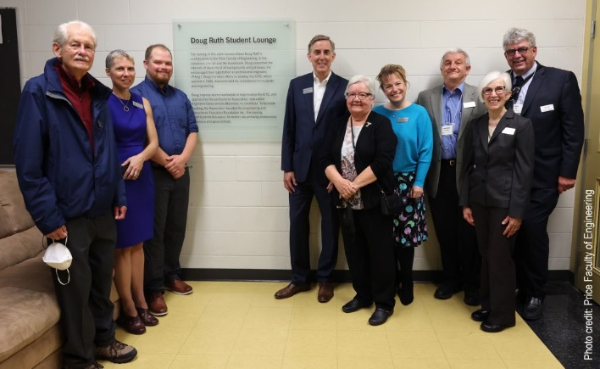
The existing student lounge in the Engineering Information and Technology Complex (EITC) will bear the name Doug Ruth Student Lounge for 15 years, commencing September 2022.

A plaque (wording below), dedicated on September 23 during the 2022 Homecoming Week, commemorates Doug’s work with students and his efforts in raising funds for the EITC.

Wording on the plaque:

The naming of this room honours Dean Doug Ruth’s contributions to the Price Faculty of Engineering. In the classroom, the lab and the boardroom, Doug supported the interests of students of all backgrounds and pathways. He encouraged their registration as professional engineers (P.Eng.). Doug’s tireless efforts to develop this EITC, which opened in 2005, demonstrated his commitment to students and engineering.
L to R: Dave Ennis, Director; Dr. Marcia Friesen, Dean, Price Faculty of Engineering and ex-officio Director; Dawson Switzer, Senior Stick; Dr. John (Jay) Doering, Director; Bev Ruth; Amber Anderson Skrabek, Director; Lawrence Ferchoff, Director; Nirdosh Ganske, EGEF President; Allan Silk, EngGeoMB President and Board Liaison to EGEF

Doug inspired alumni worldwide to help finance the EITC, and approached the professional Association, now called Engineers Geoscientists Manitoba, to contribute. To facilitate funding, the Association founded the Engineering and Geoscience Education Foundation Inc., the naming contributor to this space. Its donors are primarily professional engineers and geoscientists.

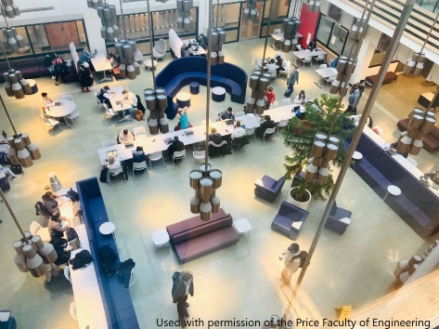
The Price Faculty of Engineering used the $50,000 gift in combination with other donor gifts toward a refresh of the Donald W. Craik Engineering Library into a more modern student learning space.

Past Presidents’ Book Project Donates Texts to UM Engineering Library
In 2005 the Past Presidents Committee of Engineers Geoscientist Manitoba decided to purchase publications to be donated to the Engineering Library at the University of Manitoba in recognition of former presidents of the Association. These publications were paid for by funds donated to the Engineering and Geoscience Education Foundation Inc. by past-presidents of the Association. These publications will be available to assist engineering students for years to come.
Donald W. Craik Engineering Library, Price Faculty of Engineering

To date, the Past Presidents’ Committee has donated approximately 95 publications at a cost of $11,689.20 to the Donald W. Craik Engineering Library. Additional information on the Past Presidents’ Book Project is available on the Engineering and Geoscience Education Foundation website (https://egef.ca/) where individuals may make credit card donations to support the Book Project (https://egef.ca/donate-to-a-current-project/) and other programs of the Foundation.

EGEF Board Extends Thanks to Supporters
The EGEF Foundation would like to acknowledge and thank the following 2022 donors:

C.E. Anderson | W.C. Boyce | S. Brown | D.G. Chapman | T.J. Cornell
F. Cross | J.R.C. Doering | D.A. Ennis | L. Ferchoff | N.P. Feschuk
M. Ganske | N. Ganske | J. Hosang | R.C. Isaak | R.A. Johnson
K. Le | G.S. Lodha | I. Mikawoz | A. Ogale | A. Pawlikewich
A.H. Permut | A.J. Pollard | C.L. Stewart | E.C. Syme

Foundation Financial Statements for the Period Ending December 31, 2022
Engineering and Geoscience Education Foundation Inc.
Income Statement from January 1, 2022 to December 31, 2022
REVENUE |  |  |  | EXPENSE
Revenue |  |  |  | General & Administrative Expenses
Individual Engineering Donations | 200.00 |  |  | Advertising & Promotions |  | 6,373.34
Total Engineering Donations |  | 200.00 |  | Bank Charges |  | 104.60
Individual Geoscience Donations | 250.00 |  |  | Square Credit Card Charges |  | 116.09
Total Geoscience Donations |  | 250.00 |  | Depreciation |  | 15.25
Individual Unrestricted Donations | 1,190.00 |  |  | Insurance |  | 823.90
Total Unrestricted Donations |  | 1,190.00 |  | Meeting Expenses |  | 276.50
TWF- EGEF Endowment Fund Donations |  | 100.00 |  | Miscellaneous |  | 40.00
Past Pres. Eng. Library Donations |  | 825.00 |  | Office Supplies |  | 373.10
Removing Barriers General Donations | 9,000.00 |  |  | Postage |  | 25.22
Total Special Projects Donations |  | 9,000.00 |  | Training for Board & Staff |  | 700.00
Total Donations |  | 11,565.00 |  | Total General & Admin. Expenses |  | 8,848.00
Other Revenue |  |  |  | Foundation Donation Expenses
TWF - EGEF Inc. Fund & Grants |  | 10,957.78 |  | The Winnipeg Foundation - Endowment |  | 10,257.78
Total Other Revenue |  | 10,957.78 |  | Total Donation Expenses |  | 10,257.78
TOTAL REVENUE |  | 22,522.78 |  | TOTAL EXPENSE |  | 19,105.78
 |  |  |  | SURPLUS (DEFICIT) |  | 3,417.00
Engineering and Geoscience Education Foundation Inc.
Balance Sheet As At December 31, 2022
ASSETS |  |  |  | LIABILITIES
Current Assets |  |  |  | Current Liabilities
Royal Bank | 45,788.86 |  |  | Accounts Payable |  | 89.44
Total Cash |  | 45,788.86 |  | GST Owing (Refund) |  | 0.00
Net Accounts Receivable |  | 0.00 |  | Total Current liabilities |  | 89.44
Total Current Assets |  | 45,788.86
Investments |  |  |  | TOTAL LIABILITIES |  | 89.44
Total Investments |  | 0.00
 |  |  |  | EQUITY
Capital Assets
Computer Software | 508.41 |  |  | Designated Funds
Accum. Amort. -Furn. & Equip. | (472.82) |  |  | Engineering Trust |  | 31,966.00
Net - Furniture & Equipment |  | 35.59 |  | Removing Barriers Bursary Trust |  | 600.00
Total Capital Assets |  | 35.59 |  | Geoscience Trust |  | 178.00
 |  |  |  | Past Presidents Library Trust |  | 1,340.80
Other Non-Current Assets |  |  |  | Total Designated Funds |  | 34,084.80
Total Other Non-Current Assets |  | 0.00
 |  |  |  | Unrestricted Surpluses
 |  |  |  | Current Surplus (Deficit) |  | 3,417.00
 |  |  |  | Retained Surpluses - Previous Years |  | 8,233.21
 |  |  |  | Total Unrestricted Surpluses |  | 11,650.21
 |  |  |  | TOTAL EQUITY |  | 45,735.01
TOTAL ASSETS |  | 45,824.45 |  | LIABILITIES AND EQUITY |  | 45,824.45

(Based on the reviewed financial statements of the EGE Foundation Inc. at December 31, 2022)

Removing Barriers Bursary Program
EGEF is working to create an endowed bursary program to support students who otherwise would not have an opportunity to become professional engineers and geoscientists. EGEF will work closely with Manitoba’s universities to provide funding for needs not addressed through existing bursaries and other programs.

Engineering companies, governments, utilities and the minerals industry are all looking for new professionals with the skills required to address the many issues in a changing world, who reflect the diversity of our society. However, many students face barriers to entrance into engineering and geoscience. Students graduating from high school, and others trying to enter our professions later in their careers, may not have the background or resources necessary to complete their degrees and succeed in these professions. Many students need to consider costs such as relocation, travel, child-care and housing. These and other barriers prevent or limit enthusiastic students from realizing their dream of becoming a professional engineer or geoscientist.

Your donation will help create a new generation of engineers and geoscientists to address future challenges in Manitoba, Canada, and around the world. Please follow this link to support any of the current Foundation projects.
Engineering and Geoscience Education Foundation Inc.
382 Inglewood Street, Winnipeg, MB R3J 1X2 | | https://egef.ca/

